Worshipful Society of Apothecaries
Livery Committee

Visit to The Temple Church & Inner Temple Gardens with lunch in the Middle Temple – Wednesday 12th June 2024 @ 11:00am

The beautiful Temple Church is steeped in the history of Christendom, this country and the whole Common Law World. In 1162 the Round Church was built to be London’s Jerusalem. In 1214–19 Magna Carta was negotiated in the Temple, and its greatest hero was buried in the Church. In 1584, 1776 and 1787 from Raleigh’s expeditions through the colonial constitutions to the American Declaration of Independence and Constitution, the Temple was the birthplace of American Law.
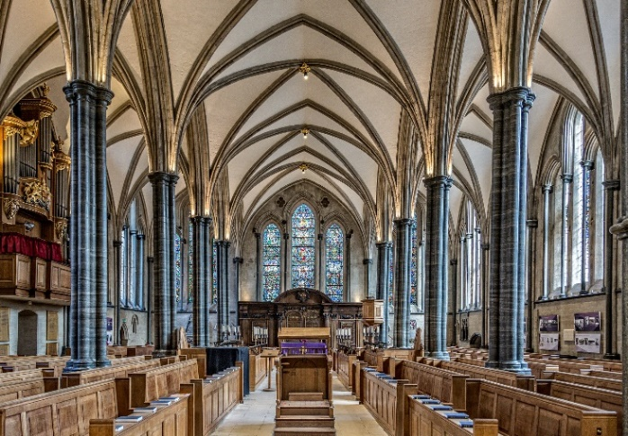
Robin Griffith-Jones the Templar will give us a guided tour of the Church and we shall then have lunch in Middle Temple, a short walk away, before joining the head gardener of Inner Temple.
If you have the time and inclination stay for Evensong at 6.00pm in Temple Church.
There is disabled access throughout all venues.

Book early
The cost will be £90 per person inclusive of a lunch at the Middle Temple.
Applications should be submitted by 1st May 2024 to Dr Susan Horsewood-Lee.
Where attendance at a function has to be cancelled after a cost has been incurred a full refund may be made at the discretion of the Officers.

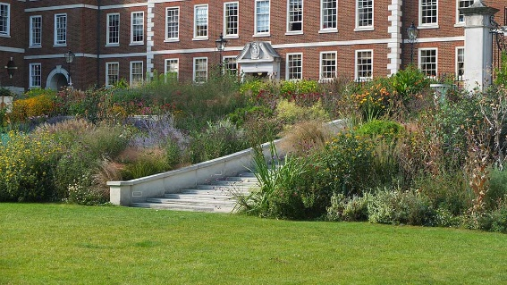
Wednesday 12th June 2024 @ 11:00am

Visit to The Temple Church - The Temple Church, Temple, London, EC4Y 7BB
And Lunch at Middle Temple - Middle Temple Ln, Temple, London, EC4Y 9BT

Booking:
To book your place(s) by Wednesday 1st May 2024 please:
- Log in to the Members’ Area of the Apothecaries website and book through the Society’s GoCardless system (as you would for a Society Dinner)
- Any problems booking in this way, please contact Beci who will be happy to assist: events@apothecaries.org
And
- Complete this form and email or scan to Dr Susan Horsewood-Lee, drsusan@chelseadoctor.com

Please reserve me…..….places for the visit to the Temple Church and lunch at Middle Temple.

Name: ..……………………………………………………………………………..

PLEASE PRINT CLEARLY:

Name: ……………..………………………………………..…………………..……………………………….

Guest(s): ……………………………………………………….…………………..……………………………

Address: ……………………………………….…………………………………………………………………

Post Code: ..……………………….. Mobile: ……………………………………………………………

Email: ……………………………………………………………..

*Please state any special dietary requirements for yourself & each guest:

…………………………………………………………………………………………………………………………

