Worshipful Society of Apothecaries
Livery Committee

Visit to Linnean Society with lunch at Café Murano –
Wednesday 24th January 2024 @ 11:00am

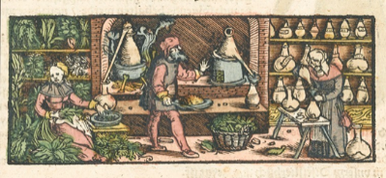

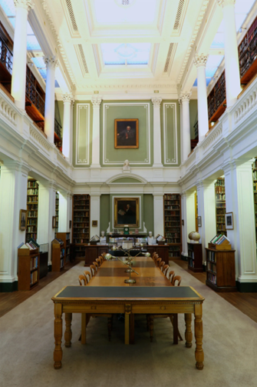
The visit will include a short introduction and film, questions, and answers. Then we shall browse through the library and herbals with the very knowledgeable staff. Followed by lunch nearby at Café Murano – One of the best Italian restaurants in London.

Book early

The cost will be £80 per person inclusive of a 3-course lunch with wine at Café Murano.

Applications should be submitted by 15/12/2023 to Dr Susan Horsewood-Lee. Where attendance at a function has to be cancelled after a cost has been incurred a full refund may be made at the discretion of the Officers.

Please email or send the tear off strip with payment no later than 15th December 2023
---------------------------------------------------------------------------------------------------------
Wednesday 24th January 2024 @ 11:00am

Visit to Linnean Society (no disabled access) - Burlington House, Piccadilly, London W1J 0BF
And Lunch at Café Murano (no disabled access) - 33 St James's St, St. James's, London SW1A 1HD

Booking:
To reserve one or more places please complete this form and email (Dr Susan Horsewood-Lee) drsusan@chelseadoctor.com attaching the completed form or copy the relevant text into your email.

To make payment:

Either I shall pay by bank transfer:
‘WSA Livery Committee’, Sort Code: 40-46-08; Account no: 92018829
Please reference with “[your Surname]/24.01.24”.

Or I enclose my cheque for £ ............
Please make payable to ‘WSA Livery Committee’.
Post the completed form together with your cheque to Dr Alan Collett, Hornbeam Cottage, New Road, Blakeney, NR25 7NZ.
Name: ..……………………………………………………………………………..

PLEASE PRINT CLEARLY:

Name: ……………..………………………………………..…………………..……………………………….

Guest(s): ……………………………………………………….…………………..………………………………

Address: ……………………………………….…………………………………………………………………

Post Code: ..……………………

Mobile: ……………………………………………………………

Email: ……………………………………………………………..

*Please state any special dietary requirements for yourself & each guest:

…………………………………………………………………………………………………………………………

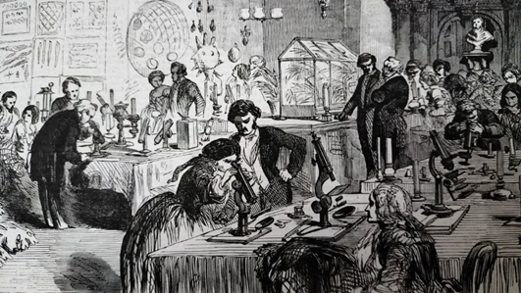
All applications and receipts of money will be acknowledged.

