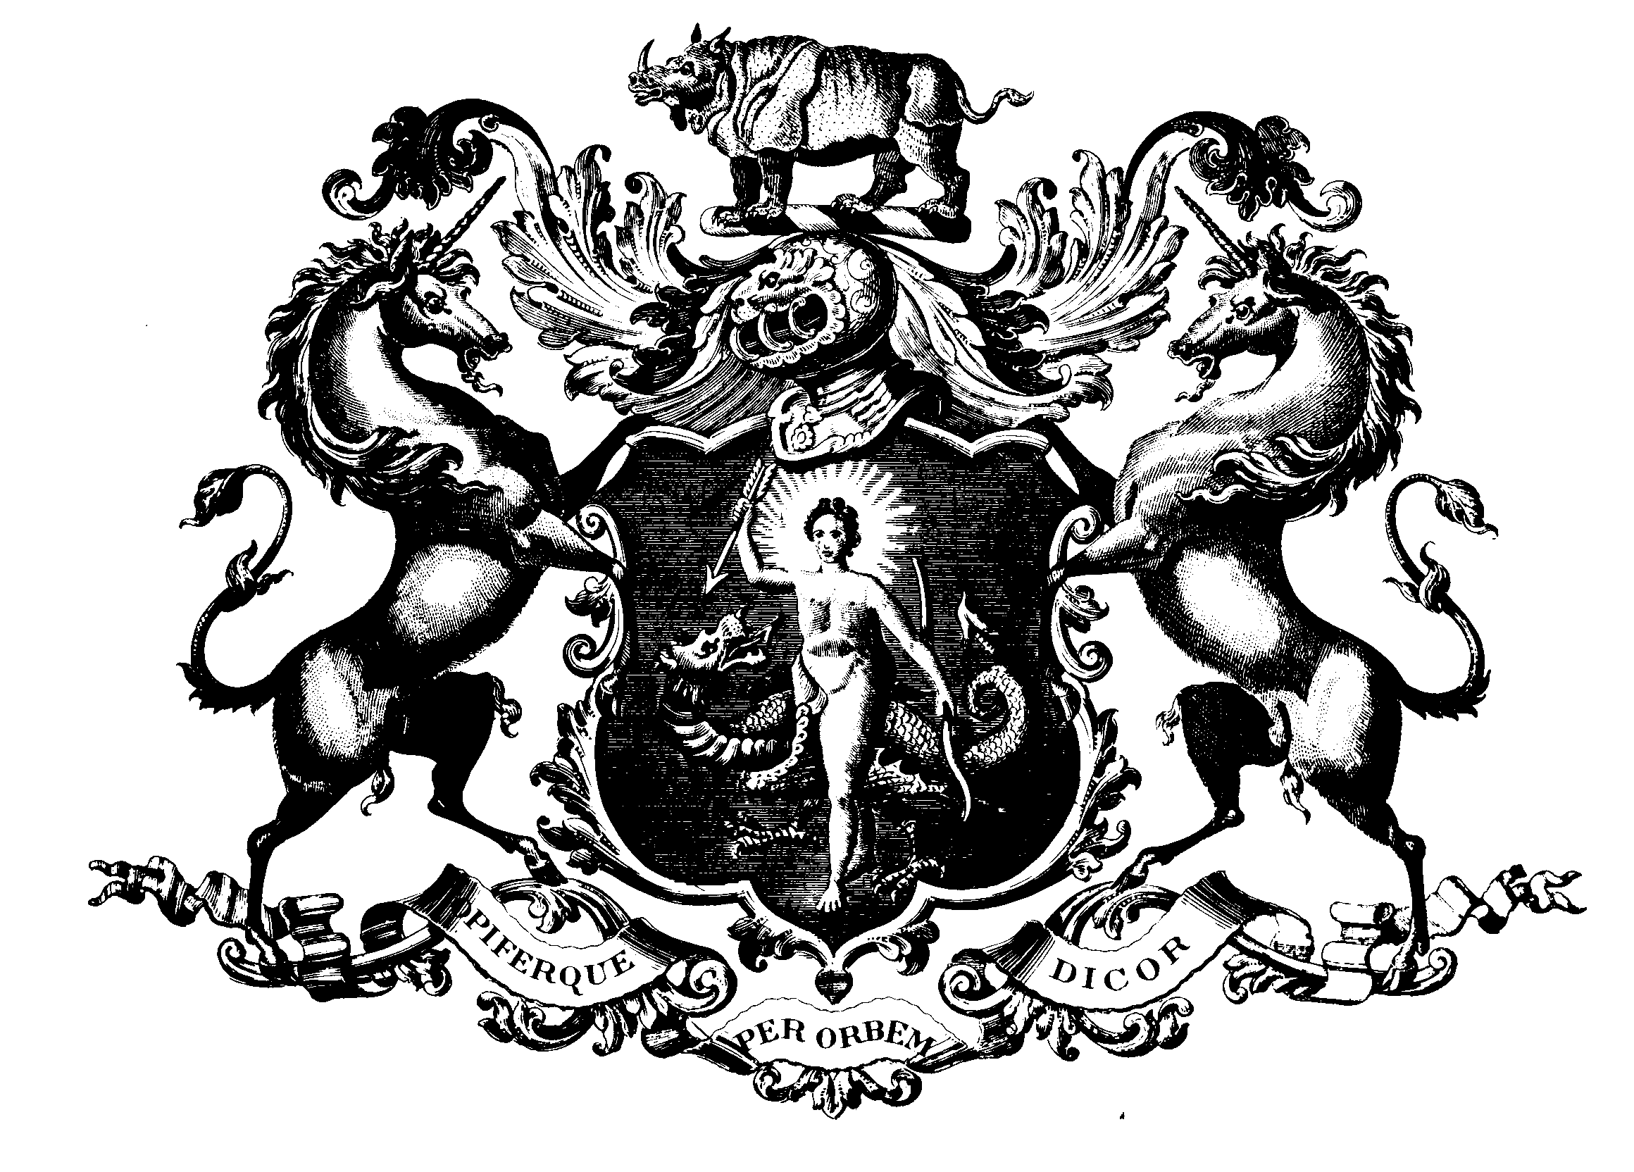

THE SOCIETY OF APOTHECARIES OF LONDON

Diploma in The Medical Care of Catastrophes

12th & 13th December 2011

The following candidates have satisfied the Examiners: -

256 | Davy Bovens
257 | Mirjam van den Burg
258 | Lieke Maria Delemarre
259 | Laura Faut
260 | Alexander Glasbergen
261 | Ilse Oud
262 | Pim Johannes Paulus Schraven
263 | Youri Vincent Versloot
264 | Roy Petrus Eliza Wiche
265 | Iris Sophia Dral
266 | Hubertus Jan van der Werf

Mrs J M E Maclean
Registrar

