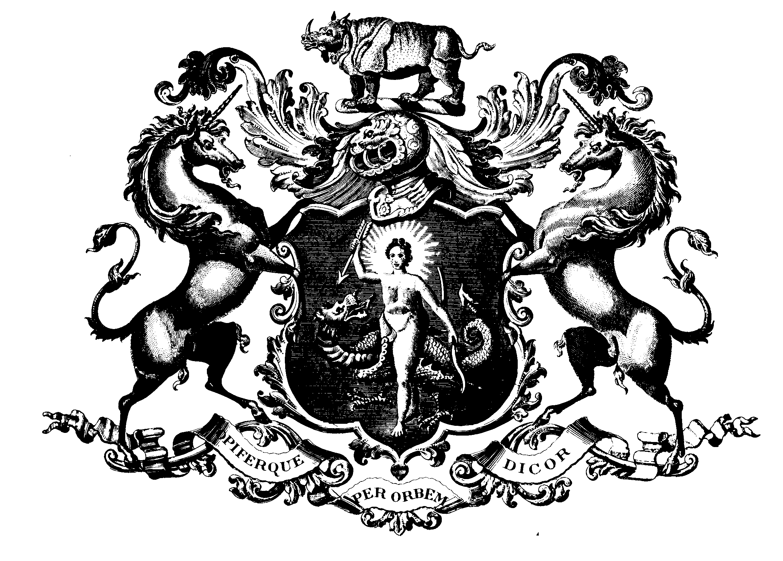

THE SOCIETY OF APOTHECARIES OF LONDON

Diploma in The Medical Care of Catastrophes

8th, 18th & 19th April 2011

The following candidates have satisfied the Examiners: -

Marcela Aguirre
William Ambler
Jon William Barratt
Peter George Beresford Jones
Sarah Elizabeth Bremner
Andrew Buckley
William Paul Buxton
Jonathan Clark
Ruth Mary Creamer
Rhys Lewis Davies
Charles Duffield
Jennifer Fox
Sarah Jane Gillingham
James Peter Gough
Sophia Grobler
Rachel Howes
Matthew David Julian
Oliver Richard Laird
Charles Francis Lampl
Thomas David Linton
Max Marsden
James Monteiro de Barros
Sarah Nelson
Jason O'Neill
Timothy Pearkes
Andrew Timothy Pelham
Rachel Elizabeth Phillips
Sarah Louise Poyner
Edward Mark James Pretsell
Oliver James Quantick
Louise Amy Robiati
Adam Staten
Patrick Andrew Hanwell Wilkinson
Matthew Wordsworth
Mrs J M E Maclean
Registrar

